The Challenge – make the ultimate Paper aeroplane

Construct a squad of paper planes and estimate how far each plane will fly.
- Give each person in your family who is involved in this challenge a piece of A4 paper.
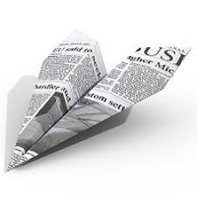
2.Collect the following: a pair of scissors (for some plane designs), a ruler to help with folding and to measure the variables such as wingspan or tail height, a tape measure to measure flight distance (optional); a stopwatch to measure flight time (optional); and colouring pens to decorate your designs (optional).
3.Start designing and making paper planes. Google making paper aeroplanes to find some interesting designs

Even though you are competing with other family members to see whose plane can fly the farthest, talk with each other about the positives, negatives and interesting points of each design to help make everyone’s plane better.
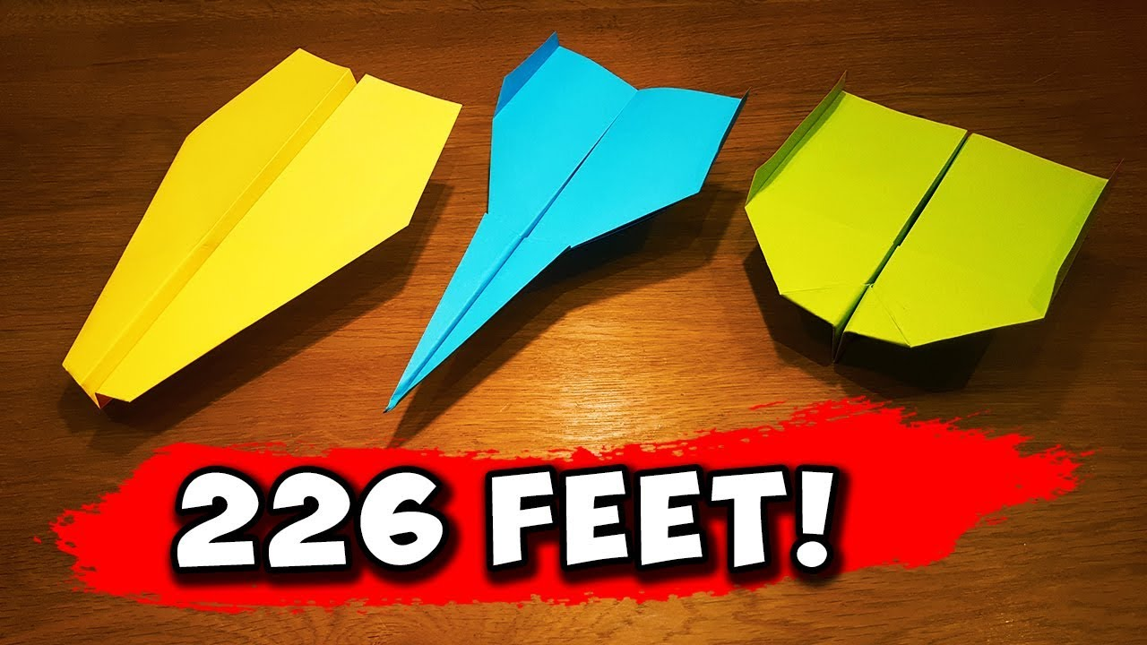

4. Once everyone is satisfied with their plane, draw a table where each person records an estimation of how far their plane might fly and how long their plane might stay in the air. Think about units of measurement that could best be used for distance – would metres, centimetres or millimetres be best? Think about units of measurement that could best be used to record flight time. Do you think hours, minutes or seconds would be best?

- Launch your planes. 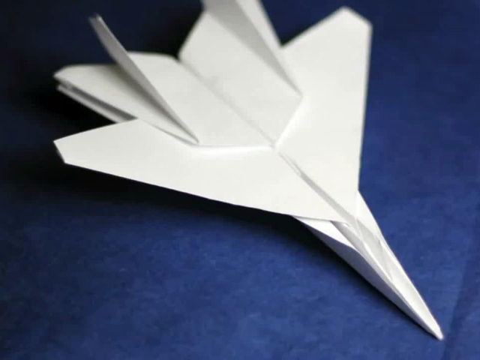

6. Grab a camera to capture images or video of your planes.

- Reflect: who in your family made the plane that flew the furthest? Who in your family made the nearest estimations regarding their plane’s flight distance and time in the air?

Scaffolding or Extension activities

Why do you think certain planes flew further than others. Investigate the differences mathematically by measuring the variables such as wingspan, shape of the wings, area of the wings and tail height.
You could create a tally chart, bar chart or even a scatter graph plotting the variables.
You could classify the type of shapes you create during the folding of the paper.
You could try to work out the percentage difference certain changes make.
You could investigate the effect of Lift, Thrust and Gravity on your planes

We cant wait to see what you create.
The Maths Department.

